ASSIGNMENT 3

M.Ganeshkarthick(192321138)

1) Write java Program for Consider a scenario, Bank is a class that provides functionality to get rate of interest. But, rate of

interest varies according to banks. For example, SBI, ICICI and AXIS banks could provide 8%,

7% and 9% rate of interest.(Method Overriding)

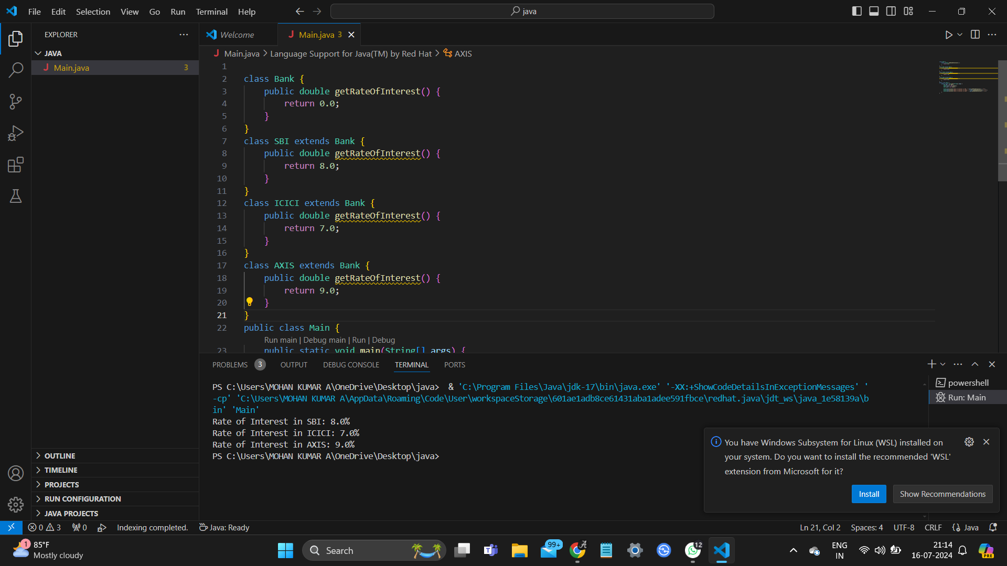

2) . Develop a JAVA code to display the balance. Include the following members:

• Design a class to represent a bank account.

• Data Members: Name of the depositor, Account number, Type of account(Savings/Current), Balance amount in the account(Minimum balance is Rs.500.00)

• Methods:

1. To read account number, Depositor name, Type of account.

2. To deposit an amount (Deposited amount should be added with it)

3. To withdraw an amount after checking balance(Minimum balance must be Rs.500.00

Note : Assume that balance amount = 10000

